

Dr. Nathan, Anderson inc.
2019-07-30
Dr. Anderson
10145 Anna Mount Suite 659, Lake Brandon, DC 55128
Phone: 4063984640
Fax: 3912130075

Re: Victoria, Weber
PHN: 6822756915
Birthdate: 30-Jan-1960
Address: 067 Bryant Loop, New Alexis, IA 74188
Patient number: 9569941212

To Whom It May Concern:

This is a medical letter to state the above patient is pregnant with expected delivery date of 16-Apr-2025. Hoping this information is satisfactory for your requirements.

Thank you.

Sincerely,
Dr. Nathan, Anderson
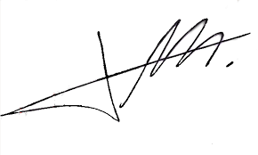
FRCS© NCMP
Clinical Assistant Professor, UBC
Department of Obstetrics and Gynecology SMH

